`



EDA & CLASSIFICATION REPORT

Dataset shape: 253680 rows × 22 columns (source: CDC BRFSS 2015, UCI ML Repository id=891). KNN/Naive Bayes trained on a stratified 15,000-row sample

- Data Quality Report
Missing values were imputed using class-conditional medians before this report was generated.

 | dtype | cardinality
HighBP | int64 | 2
HighChol | int64 | 2
CholCheck | int64 | 2
BMI | int64 | 84
Smoker | int64 | 2
Stroke | int64 | 2
HeartDiseaseorAttack | int64 | 2
PhysActivity | int64 | 2
Fruits | int64 | 2
Veggies | int64 | 2
HvyAlcoholConsump | int64 | 2
AnyHealthcare | int64 | 2
NoDocbcCost | int64 | 2
GenHlth | int64 | 5
MentHlth | int64 | 31
PhysHlth | int64 | 31
DiffWalk | int64 | 2
Sex | int64 | 2
Age | int64 | 13
Education | int64 | 6
Income | int64 | 8
Outcome | int64 | 2

- Visualizations

Boxplots
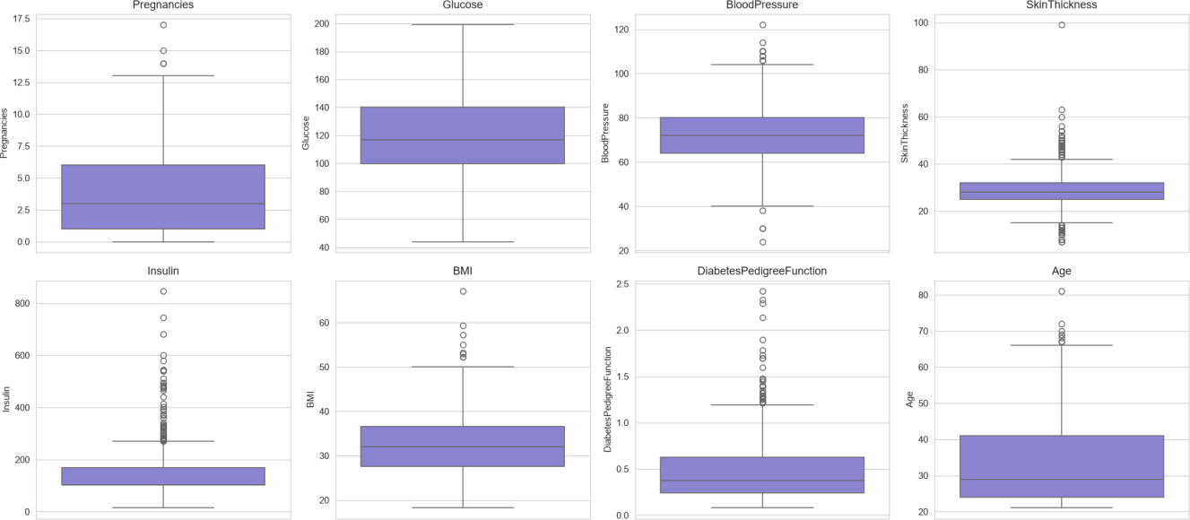
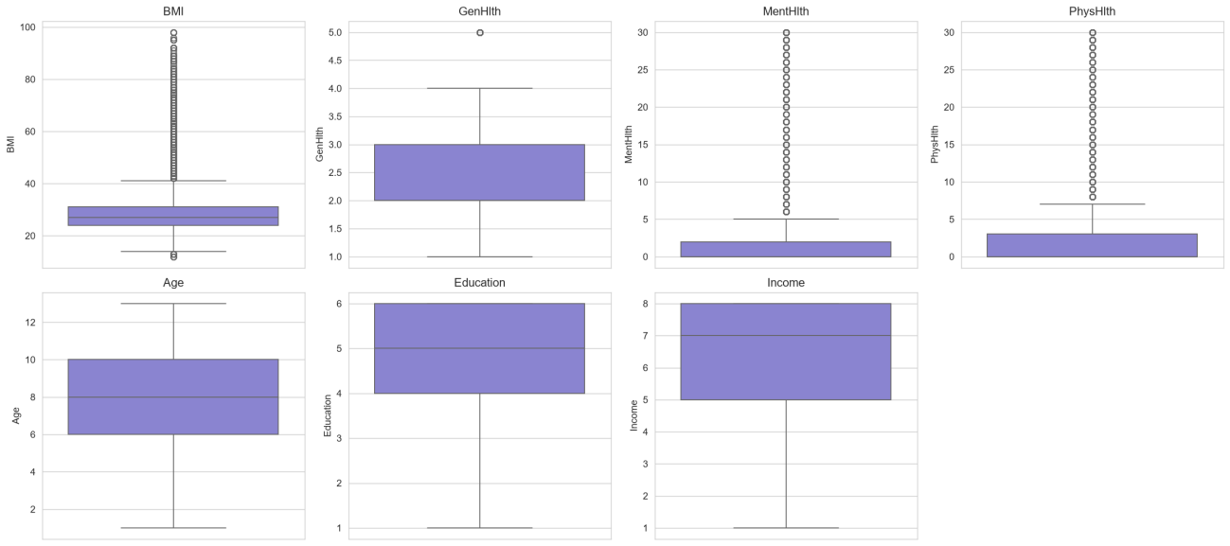

Histograms
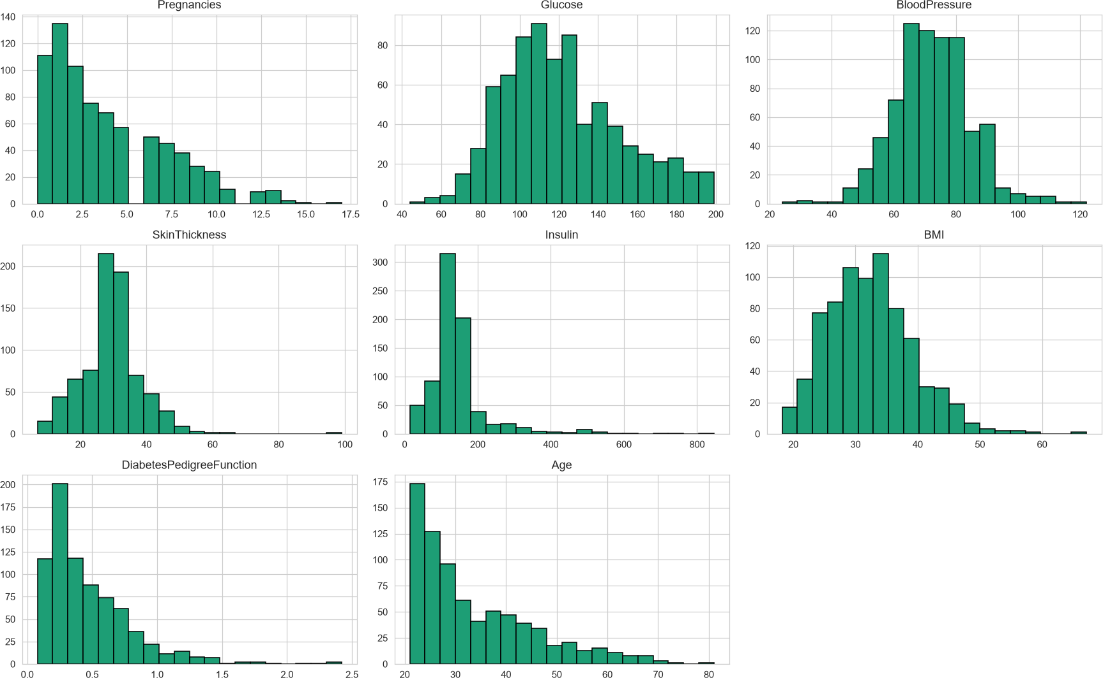
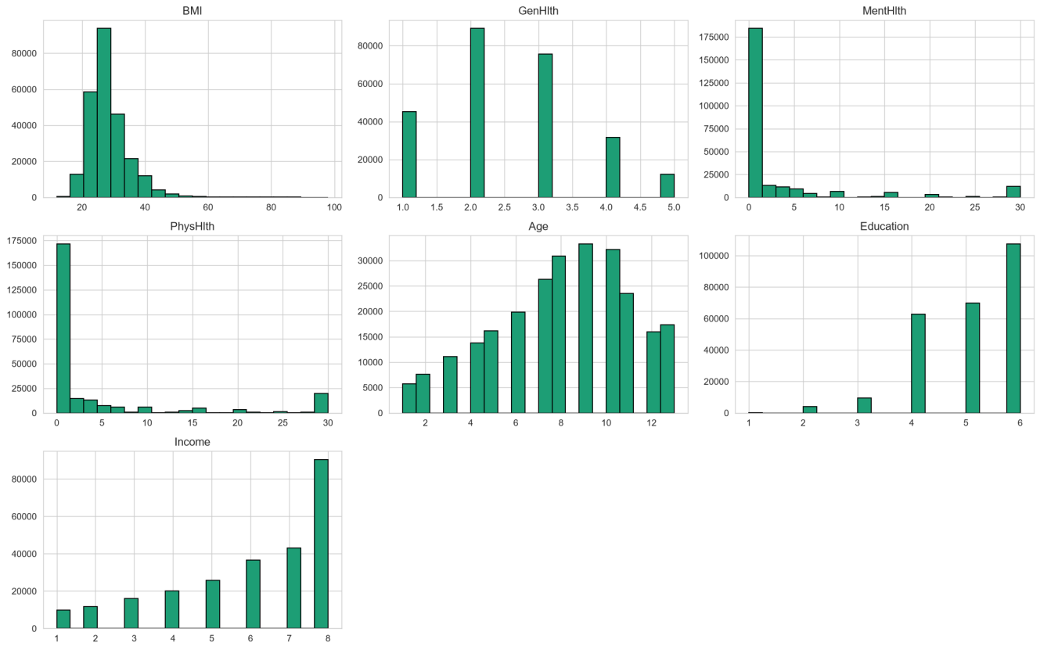

Scatter: Glucose vs BMI
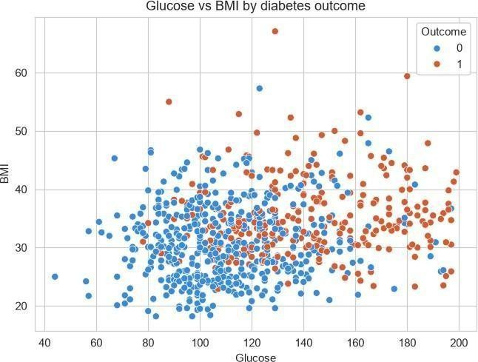
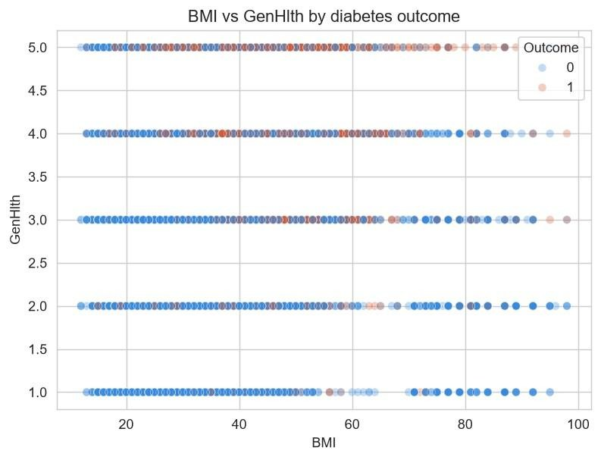

Correlation heatmap

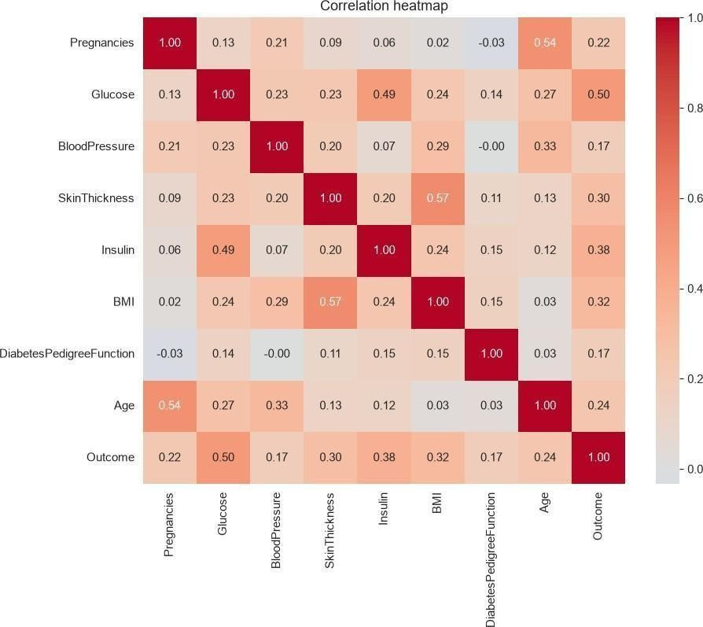
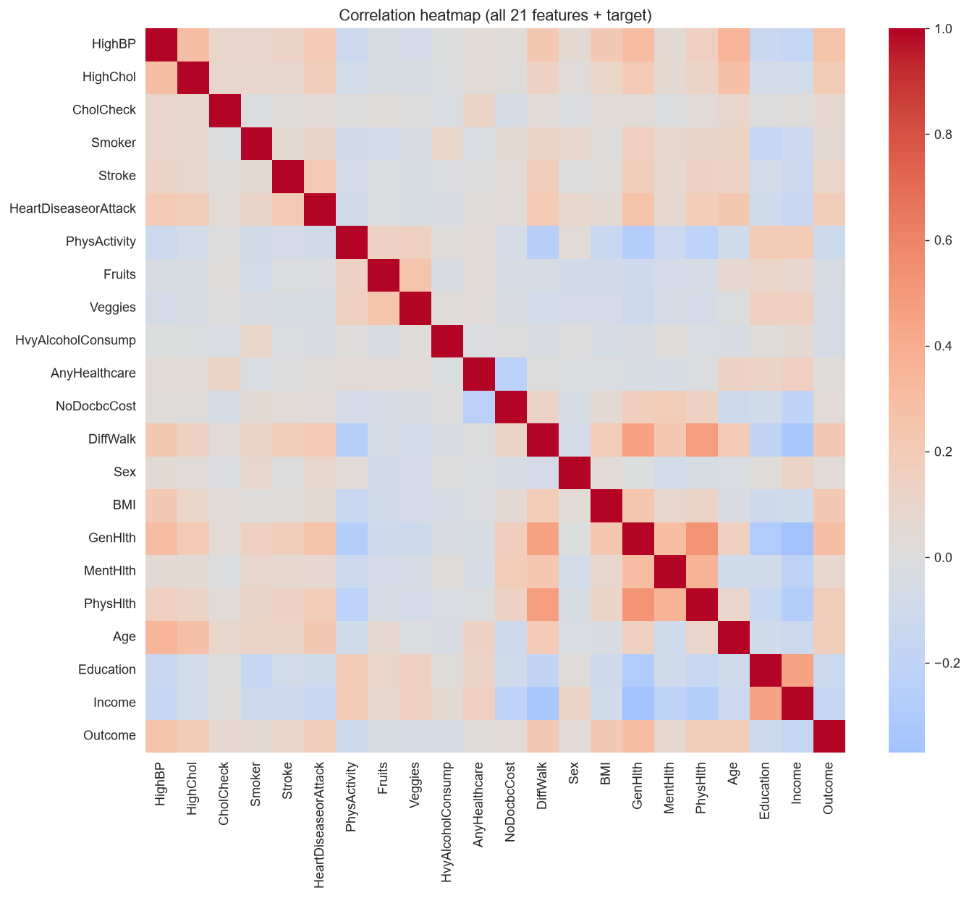

Class Distribution

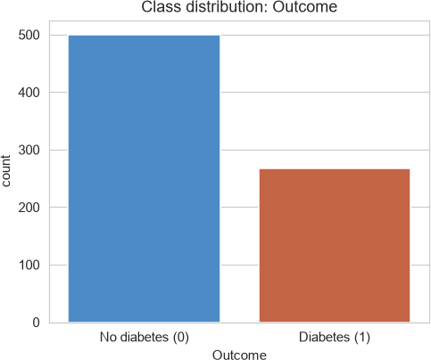
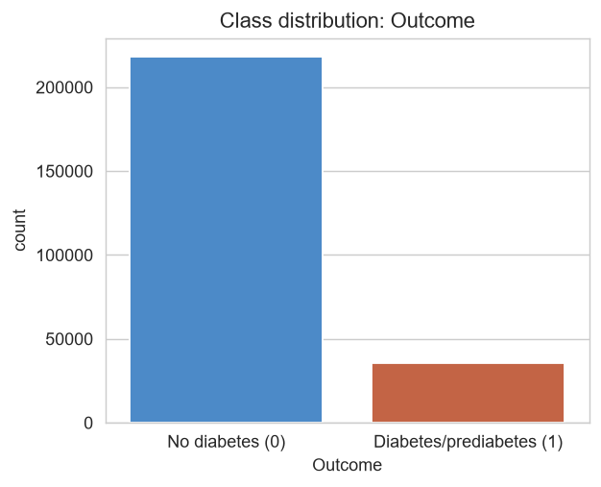

- Model Results (KNN vs Weighted KNN vs Naive Bayes)
7

Model | Accuracy | Precision | Recall | F1-score | ROC-AUC
KNN (k=5, uniform) | 0.704 | 0.261 | 0.612 | 0.366 | 0.709
Naive Bayes | 0.712 | 0.290 | 0.734 | 0.416 | 0.781
Weighted KNN (k=5, distance) | 0.711 | 0.265 | 0.605 | 0.369 | 0.710

- KNN performance across k values

k | Model | Accuracy | Precision | Recall | F1-score | ROC-AUC
1 | KNN (k=1) | 0.772 | 0.281 | 0.409 | 0.333 | 0.62
3 | KNN (k=3) | 0.726 | 0.261 | 0.526 | 0.349 | 0.684
5 | KNN (k=5) | 0.704 | 0.261 | 0.612 | 0.366 | 0.709
7 | KNN (k=7) | 0.683 | 0.253 | 0.651 | 0.364 | 0.725

Weighting scheme :
Uniform (all neighbors counts equally)
k | Model | Accuracy | Precision | Recall | F1-score | ROC-AUC
1 | KNN (k=1) | 0.772 | 0.281 | 0.409 | 0.333 | 0.620
3 | KNN (k=3) | 0.726 | 0.261 | 0.526 | 0.349 | 0.684
5 | KNN (k=5) | 0.704 | 0.261 | 0.612 | 0.366 | 0.709
7 | KNN (k=7) | 0.683 | 0.253 | 0.651 | 0.364 | 0.725
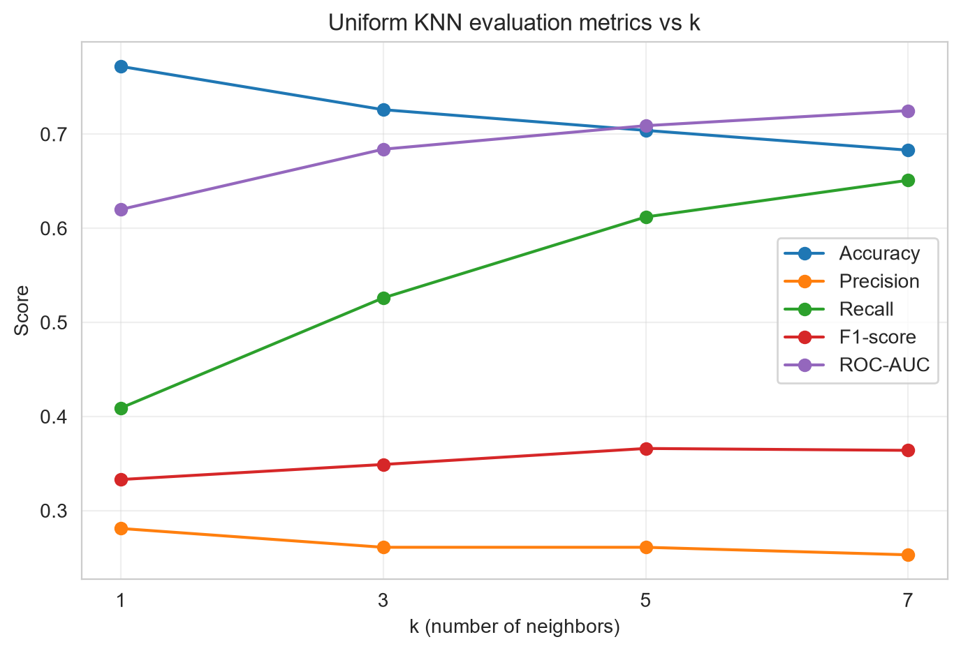

Uniform KNN: best F1-score at k=5 (F1=0.366).

Distance –Weighted (Closer neighbors Count more)

k | Model | Accuracy | Precision | Recall | F1-score | ROC-AUC
1 | Weighted KNN (k=1) | 0.772 | 0.281 | 0.409 | 0.333 | 0.620
3 | Weighted KNN (k=3) | 0.729 | 0.262 | 0.522 | 0.349 | 0.684
5 | Weighted KNN (k=5) | 0.711 | 0.265 | 0.605 | 0.369 | 0.710
7 | Weighted KNN (k=7) | 0.694 | 0.259 | 0.641 | 0.369 | 0.726

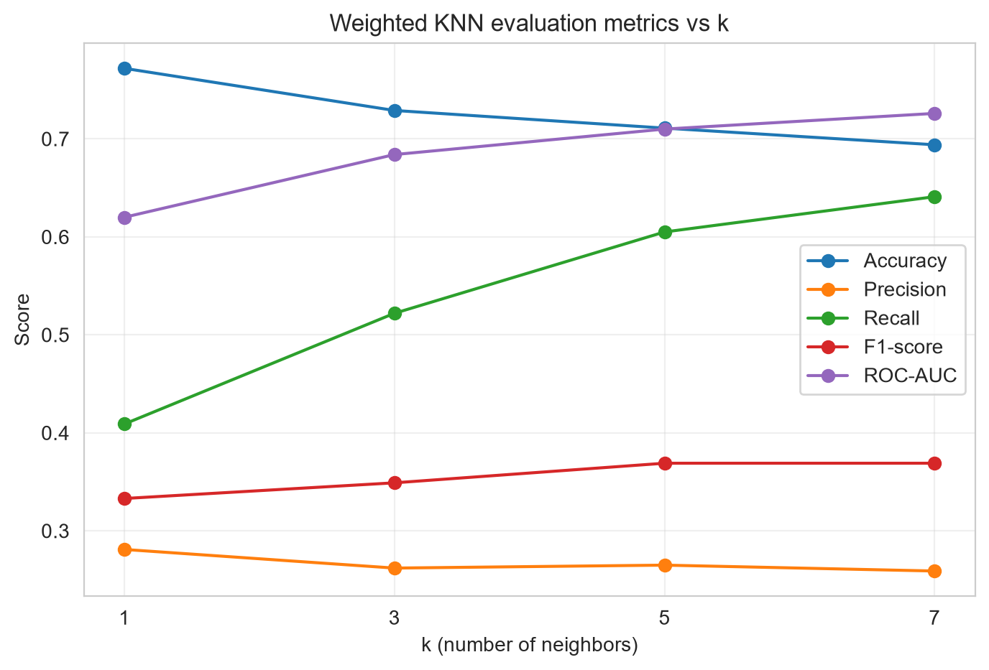

Weighted KNN: best F1-score at k=5 (F1=0.369).

- Best Uniform KNN vs Best Weighted KNN vs Naive Bayes

Model | Accuracy | Precision | Recall | F1-score | ROC-AUC
KNN (k=5, uniform) | 0.704 | 0.261 | 0.612 | 0.366 | 0.709
Weighted KNN (k=5) | 0.711 | 0.265 | 0.605 | 0.369 | 0.710
Naive Bayes | 0.712 | 0.290 | 0.734 | 0.416 | 0.781

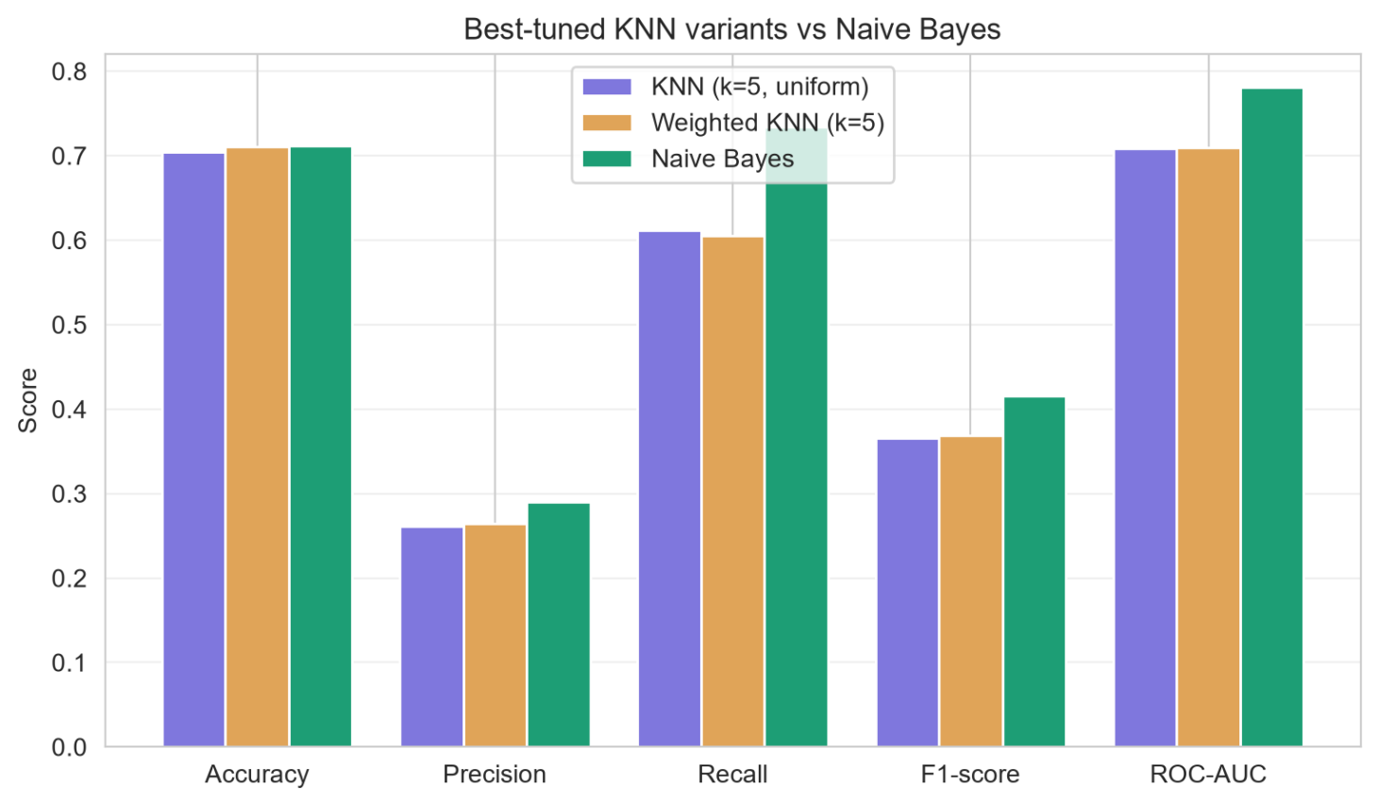
Higher F1-score: Naive Bayes.

